Investigation of How the Increase in Mass of a Projectile Affect the Range of a Trebuchet

**Personal Engagement**

Ever since I was young, I was fascinated by history and more specifically the medieval times. I used to watch documentalist programs and videos about different cities and battles that took place. In those times, there were frequent wars and conflicts so technology was improved for the sake of it. One of these weapons, was the trebuchet. It was extraordinary for me to find out that they existed and that thousands of years ago engineers managed to design these weapons.

Wondering about the topic of my physics internal assessment, my teacher told me about a trebuchet he had previously crafted himself out of wood with the help of my previous physics teacher. This brought me my topic for the exploration.

However, my initiative came when we wondered about the capacities of his creation, which sparked my curiosity to test this device. We had discussed how his previous students had used the trebuchet with golf balls and small objects but never gone any further. In our conversation, we concluded that the best way to find out was to experiment with it

**Research Question:**

How does the mass of a projectile affect the range of a trebuchet, and which is the ideal mass for the projectile?

**Background Information:**

The trebuchet which will be used is a **sliding sling trebuchet,** made up of wood mainly, built up with screws and nuts to keep it together and allow it to rotate. It has a rope attached that releases at one end at a given height so as for the projectile to fire. The projectiles which will be used are ones that I built using dirt in a bag and covering it with tape so as to hold them in place. I made sure to weight them after the tape was applied so as to have a more certain approximation of its real mass. I built a total of 10 projectiles of different mass for this experiment. The different masses are: 8.21 g, 12.30 g, 23.70 g, 41.81 g, 58.40 g, 71.61 g, 81.09 g, 92.53 g, 103.92 g, 121.20 g. I chose these masses with the 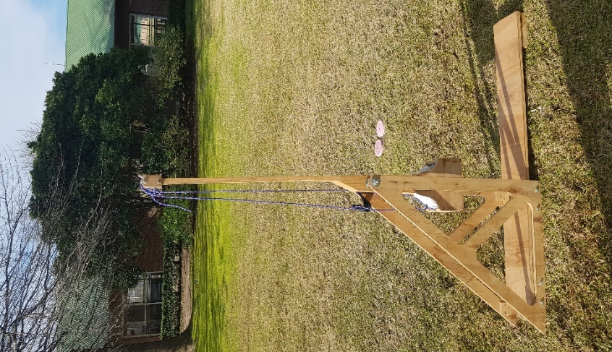purpose of having a wide variety of data, but had to adjust the values to the limitations of the trebuchet, as a projectile too small or big would cause problems in the device.

Figure 1: This is the trebuchet I used for the experiment. As it can be noticed it is made up of wood and screws mainly. The part of the counterweight can also be seen with the bag of dirt. In the background the yard and the school´s dining room is evidenced.

The Trebuchet starts to operate as follows:

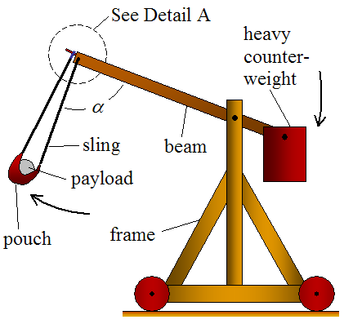

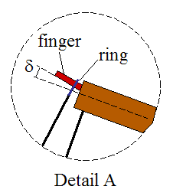

Figures 2 and 3. Illustrated Diagrams of a trebuchet and how they operate.

Diagrams obtained from: *Trebuchet Physics – How A Trebuchet Works*

*As you can see, the counterweight pivots around a much shorter distance than the payload end. The advantage of this is that the payload end of the beam reaches a much higher linear velocity than the counterweight end of the beam. This is the principle of mechanical advantage, and is what allows the payload to reach a high launch velocity. However, because the counterweight pivots around a much shorter distance, its weight must be much greater than the weight of the payload, to get a high launch velocity.*

*The sling releases when a certain angle α is reached. At this point the ring (which is connected to the sling and loops around the finger for support) slips off and the payload is launched. The release angle α can be adjusted by changing the finger angle δ. For a greater δ the release angle α increases. For a smaller δ the release angle α decreases.[1]*

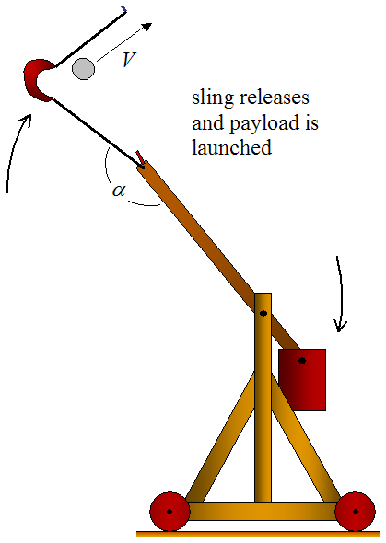

Figure 4: Release of the projectile. Image from: *Trebuchet Physics – How A Trebuchet Works*

*As the beam rotates clockwise (due to the falling counterweight), the payload experiences centripetal acceleration which causes it to move outwards (since it is unrestrained). This results in a large increase in linear velocity of the payload which far exceeds that of the end of the beam to which the sling is attached. This is the heart of trebuchet physics and is the reason a trebuchet has such great launching power.[2]*

The aim of this experiment will be to measure each of the distance travelled by the dirt projectiles and based on the data produced I will aim to find out which of them will have the best proportion of mass and distance travelled. Another affecting issue in this experimentation will be the size of the projectile and the limitations presented by the device itself.

Despite projectile motion being part of the IB Physics contents, this investigation will not aim to prove this theory or calculate for example the energy within the system or the speed of the projectiles. This is because the apparatus presents strong limitations in the form of the angle at which the projectile is fired as the design of the finger’s angle is modified when the trebuchet fires, making impossible the appropriate measurements. The transfer of potential energy (Ep) into kinetic (Ek), given that the trebuchet disperses an important percentage in its movement due to design flaws. It is for these considerations that the physical theory of this experiment won´t be evaluated deeply in calculus, but an analysis of experimental results.

**Hypothesis**

The Hypothesis I propose will possess a **fully theoretical background**. I propose there will be an **exponential decrease** in the **range** of the trebuchet **as** **mass increases.** This hypothesis derives from the equation found in Donald B. Siano’s paper:

Rm

This equation shows the theoretically maximum range of a trebuchet, where **Rm** is the **maximum range, m1** is the mass of the **counterweight**, **m2** is the mass of the **projectile**, and **h** is the **height of the counterweight from the lowest point it will reach.** This equation is obtained as follows:

*The maximum possible range that could be attained is obtained by equating the initial potential*

*energy in the counterweight with the kinetic energy in the projectile at the start of the*

*trajectory.[3]*

As the height and mass of the counterweight remained constant during the experiment, a graph of the equation can be produced by replacing the expression with:

Where Y is the maximum range, and I replaced the mass of the counterweight with 3.5 (kg), for which the mass of the projectiles in the graph will also be in that unit, and the height for 0.85m. This is just a sketch, it does not contain any obtained data.

Using a mathematical software called Geo Gebra, I obtained the following graph:

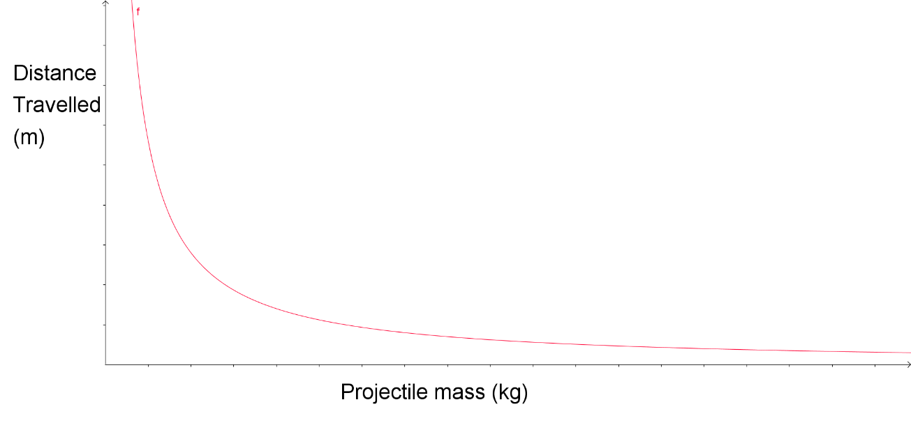As it is clear, the function is **exponentially decreasing.** However, as this is completely theoretical, the results may change in respect to the expected ones.

**Conditions previous to the experiment:**

* A flat land with grass will be used so as to reduce the bouncing of the projectiles.
* The tests will be carried out on a low-wind day so as to get better results
* The trebuchet will be loaded every time with the same counterweight so as not to alter

the results.

* There will be marks at a straight line from the trebuchet every 2 meters so as to measure the distance travelled.
* Tests on the same day so as not to be a large impact of weather
* The use of an assistant may be required.

**Methodology:**

* With the help of a student, I placed the trebuchet on a large flat land of grass.
* I measured a straight line and marked every 2 meters.
* I loaded the counterweight with a bag of dirt.
* The projectiles were fired always using the same angle of the finger.
* Every time a projectile landed, my partner rapidly marks the landing spot.
* Upon marking the spot, I measured the distance traveled and the deviation from the

center line each projectile presented.

* I took down notes of the data on a sheet of paper
* I grabbed the projectile and replaced it in the trebuchet.
* I loaded the trebuchet carefully, for an accident not to happen
* I repeated 15 times the procedure for each projectile.
* The conditions stated for the experiment where the same for every projectile

**Risk Assessment:**

One of the most important factors of any experiment is the risk or danger it might produce. In this case, for being a small trebuchet with relatively lightweight projectiles, there is not a large danger, however, the following factors will be considered:

Safety Measures:

As I used a ground near the primary school I attended, I made sure that the children were in class so that no one could get hit by any of my projectiles. Moreover, there were some birds in the area so I scared them away to avoid any damage being inflicted on them. Me and my partner were always positioned on a side of the trebuchet to minimize the dangers of being hit by the beam. Another safety I took was to inform the school teachers and authorities so as to make sure the children were not exposed and they were well informed.

Ethical Issues:

For this particular experiment I do not experience any ethical issue, as the recreation of the trebuchet is not decorated to appeal into a weapon. Moreover, I did not set up any target to shoot or aim, and so nobody would follow that tendency. It was a purely experimental environment.

Environmental Problems:

Given that I used dirt to fill in the projectiles and the counterweight, once I finished the experiment, I proceeded to re-integrate that dirt to the spot in my garden where I took it from so as not to affect any natural balance. I also made sure that the plastic bags that were left intact (4 bags) would be re-used and the ones which could not (6 bags) ended in the right trash container and not in the ground, where they could pollute the soil.

Data Analysis:

After the measurements were taken, the following data can be observed:

Table 1: Table showing the averages obtained from the raw data.

|  |  |  |  |  |  |
| --- | --- | --- | --- | --- | --- |
| **Projectile**  **Mass(g)** | **Uncertainty in projectile**  **mass (g)** | **% Uncertainty in Projectile Mass** | **Distance Travelled (m)** | **Uncertainty in Average Distance**  **(m)** | **% Uncertainty in Average Distance travelled** |
| 8.21 | 0.01 | 0.12% | 3.47 | 0.220 | 6.34% |
| 12.30 | 0.01 | 0.08% | 5.48 | 0.295 | 5.38% |
| 23.70 | 0.01 | 0.04% | 6.71 | 0.320 | 4.77% |
| 41.81 | 0.01 | 0.02% | 6.97 | 0.100 | 1.43% |
| 58.40 | 0.01 | 0.02% | 6.23 | 0.185 | 2.97% |
| 71.61 | 0.01 | 0.01% | 5.12 | 0.105 | 2.05% |
| 81.09 | 0.01 | 0.01% | 3.59 | 0.165 | 4.60% |
| 92.53 | 0.01 | 0.01% | 3.66 | 0.115 | 3.14% |
| 103.92 | 0.01 | 0.01% | 2.45 | 0.330 | 13.5% |
| 121.20 | 0.01 | 0.01% | 1.86 | 0.165 | 8.87% |

This table shows the distance travelled by each individual projectile and its mass, with the uncertainty included in the title. However, this table was produced after making the average distance travelled by each projectile 15 times (Consult in **complete table 1** of the appendix). This amount of repetitions allowed me to minimize the uncertainty, giving my results a greater precision.

As uncertainties are a key factor of any experiment, I decided to introduce the **upper-lower bound of uncertainty propagation** (UNC)[4]. Take for example the projectile of 58.40 grams.

Average distance travelled (m): To calculate the average of the distance travelled the procedure is simple. I added all of the values and divided by 15 as shown below:

= **6.23m**

*The* ***upper bound*** *is calculated by: Avg – Min: 6.23 – 6.05 = 0.18m*

*The* ***lower bound*** *is given by: Max – Avg: 6.42 – 6.23= 0.19m*

*The* ***Absolute Uncertainty*** *by using the* ***Upper-Lower Bound of Uncertainty Propagation:***

***% Uncertainty in Avg. Distance Travelled =2.97%*** *(3 s.f.)*

**The absolute uncertainty** in the mass of the projectile, which is in this case the independent variable, is always **0.01g**. This is because the digital scale which I used for the measurement had a precision of up to 2 decimal places. **The percentage uncertainty** of these weights can be calculated by first dividing 0.01g (abs. uncertainty) by the mass value and then multiply the result by 100.

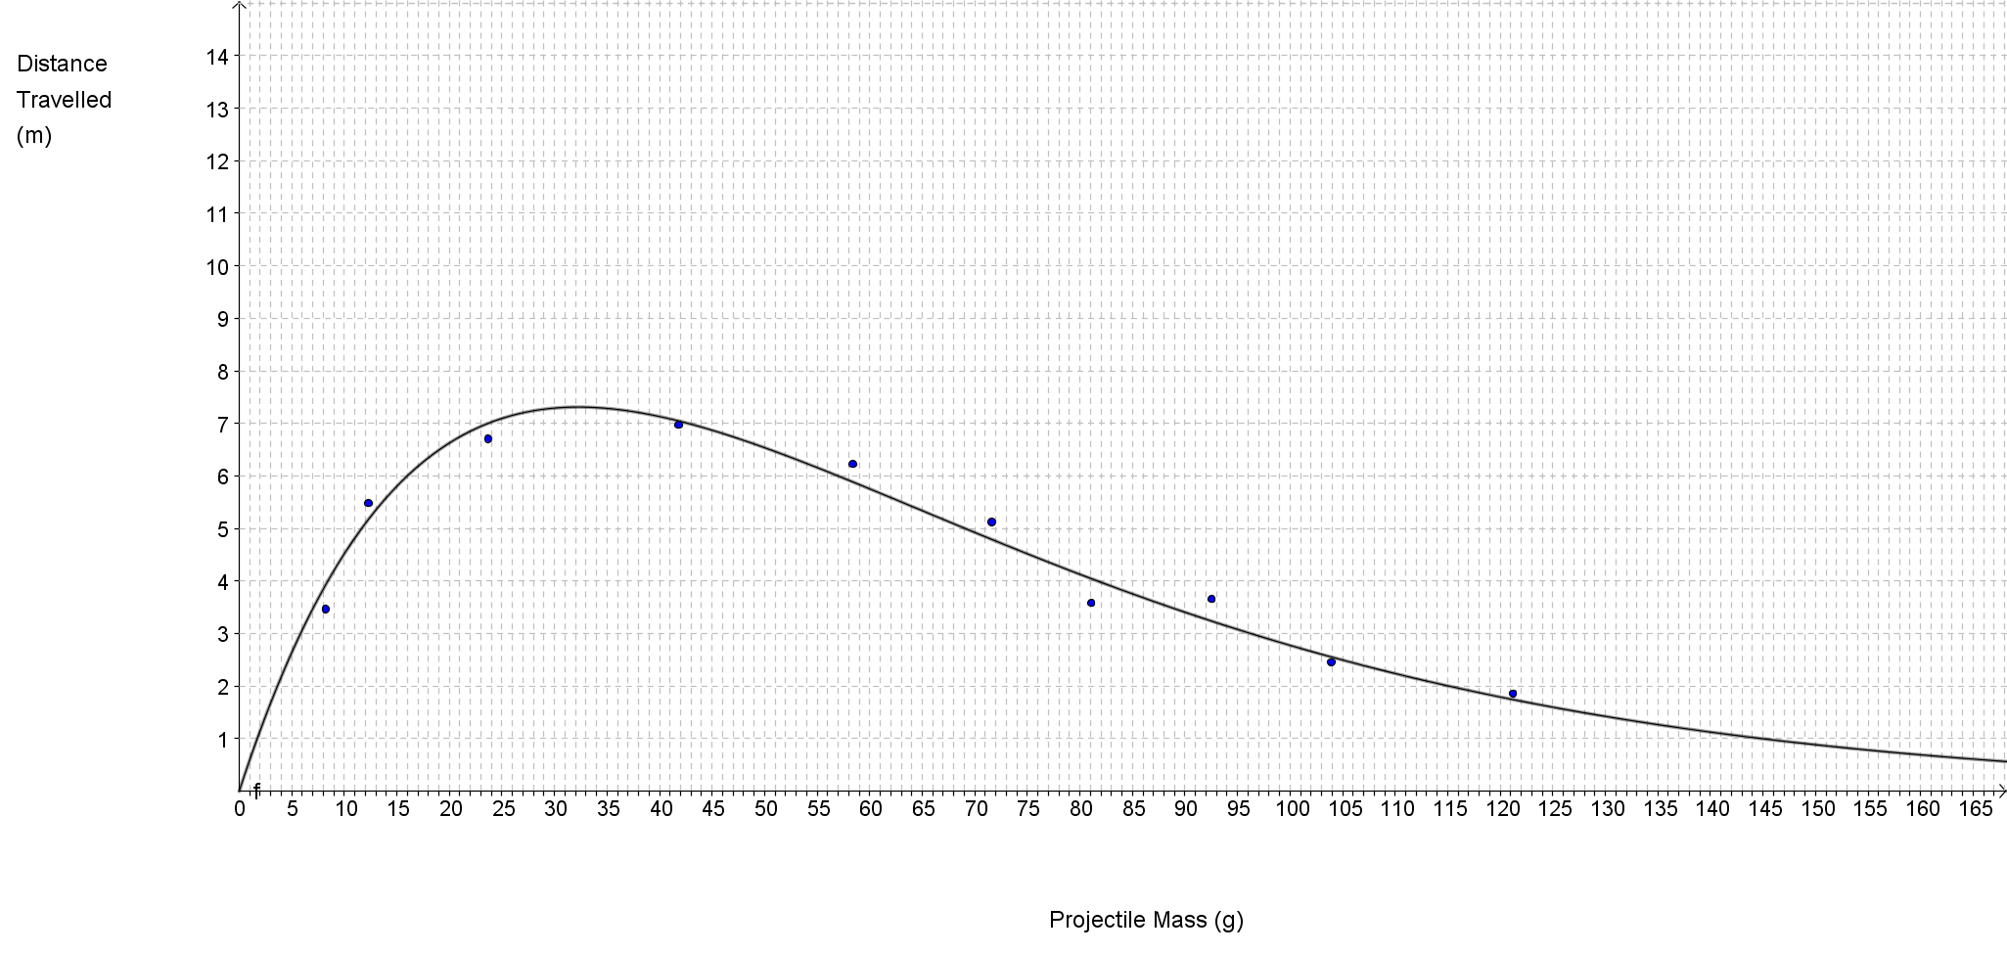In the table we can observe an increase in the distance as mass goes up but stops and the values start to fall at a certain point. After collecting the data and making the averages I proceeded to graph them using Geo Gebra.

Graph 1

This is the graph that was produced to fit best the data I gathered. In it we can observe a curve in which for a given projectile mass shot by the trebuchet, there is a distance travelled. As it may be appreciated, there is a high increase in the proportion of distance travelled for a given mass in between 0 grams and around 30 grams, at which the values form a concave down-shaped curve. After this there is what appears to be an exponential decay in the relation produced. The higher the mass, the lower the distance travelled after the mentioned point. In the graph there are no error bars, as these are too small to be appreciated.

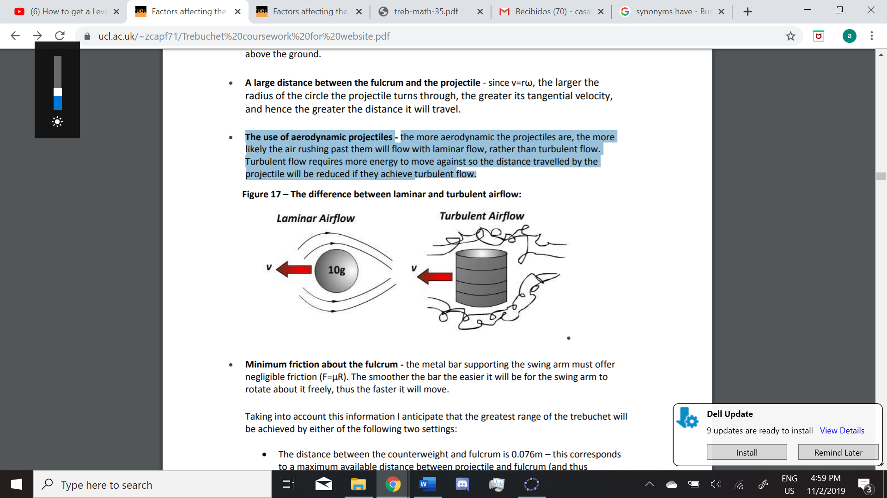This results however, do not fit in with the hypothesis proposed at the beginning of the work, and these may be for a variety of reasons. First of all, the increase in range of the projectiles from mass=0 to 30 was the greatest difference between the expected model and the actual results. This can be attributed to several issues. As their mass was too small, they could have not produced enough **tension** in the **sling** so as for the **ring** to slide off the **finger** easily and at the right time. The time it takes for the ring to slide off affects the efficiency of the device, according to Donald Siano’s paper on trebuchets. Another reason may have been the wind. Even if it was slow, it may have been proportionally larger for the smaller projectiles, affecting the range. Connected to this is air resistance, which may have altered their motion. More specifically, the aerodynamics of the projectiles. As they were made from a plastic bag and tape, their surface was not smooth, this could have caused **turbulent airflow**, which is the contrary of **laminar airflow**. *The more aerodynamic the projectiles are, the more likely the air rushing past them will flow with laminar flow, rather than turbulent flow. Turbulent flow requires more energy to move against so the distance travelled by the projectile will be reduced if they achieve turbulent flow.[5]* This is depicted in Figure 5.

Figure 5. Extracted from Lucas Stephen’s work *What affects the range of a Trebuchet?*

Furthermore, the **pouch** presented difficulties in holding the smaller projectiles, which could have altered the angle of release, releasing the projectile in a closer angle to a perpendicular line respecting the ground. This would cause a decrease in distance achieved.

Apart from this curious occurrence, the rest of the data seems to fit into the hypothesis proposed, there is an exponential decay in range as mass increases. What I proceeded to do was to investigate the ideal mass-range relationship for this trebuchet, given that the counterweight remains constant as well as all other variables. For this I proceeded to use Geo Gebra as the graphing software again. To obtain the best relationship, the Y value had to be the greatest, and according to my mathematical knowledge, a function, let us call it **f(x)**, has a maximum or minimum point when its derivative, let us call it **f ’(x)**, is equal to 0. So I indicated Geo Gebra to graph **f ’(x)** and give me the x-intercept (Where x=0). After obtaining the X coordinate, I applied mathematical concepts again. Knowing that the **derivative** of any function gives out the **gradient** of the **tangent line**, I used Geo Gebra to Graph the tangent line to **f(x)** at the X coordinate I had obtained previously and shortened its domain so as not to go over all of the 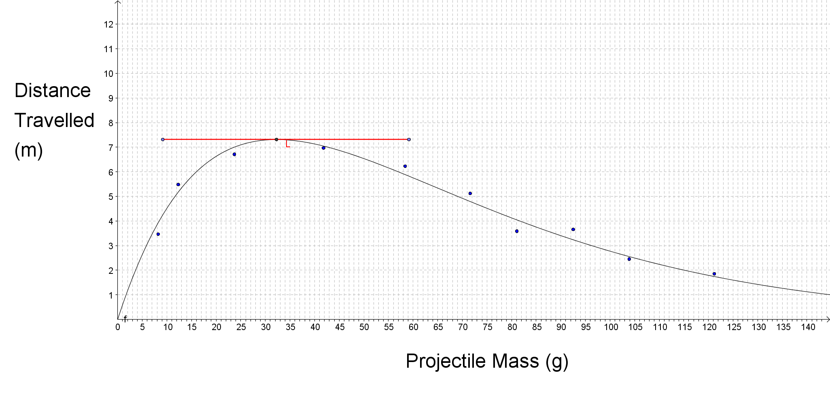screen. This is the Graph I obtained:

**Graph 2**

After these procedures, I obtained line L, the tangent to **f(x)** that intersected it at the point of coordinates (32.26 , 7.31), marked in the graph. With this information, the ideal mass-range relationship for a projectile would be of 32.26 grams for which it would reach an average of 7.31 meters. Geo Gebra also presented the equation of **f(x)** which is:

**Conclusion**

To conclude, this experiment **did not** **fully** demonstrate the **exponential decay** on the relationship between the **mass** of a projectile and the **range** achieved at firing it with a trebuchet. It instead demonstrated the practical aspects of the trebuchet and how **external factors** interact with the system and deviate the expected values of a theorical model into more real ones. Despite this, it clearly showed the exponential decay after the initial curve ends in **58.28 g** and turns into an exponential decay, so it is not accurate to state that the hypothesis was **completely** wrong. It is also correct to affirm that the values obtained only work with the exact replica of the trebuchet used in the experiment and also the type of trebuchet, which is a **trebuchet of sliding sling,** demonstrated to have an **83% efficiency** by Donald B. Siano. There are several other factors affecting the efficiency of a trebuchet, such as the **mass** of the **beam,** the **time of release** of the projectile as well as the **angle of release.** The concepts behind the increase in range from 0 (g) to **32.26 g** of the graphs involve air resistance, tension and trebuchet design flaws, which were not considered in the theoretical hypothesis.

**Evaluation and Possible Solutions**

Most of the procedure of this experiment was well designed, however there were some flaws within it and there is place for improvement

1. One problem presented was the **landing site** of projectiles**.** Even though I had a partner who helped and saw where the balls landed, there could have been a misinterpretation or bad reading of the exact landing site. This could have affected **Precision.**
2. The **Design of the Trebuchet** was correct; however, some screws and nuts were often unadjusted after firing, meaning that the mechanism was not correctly adjusted completely. We did adjust it every time we fired.
3. The **lack of quantitative data for the errors.** Even though there were several factors that affected the theoretical hypothesis, there was a large difficulty in obtaining numerical data of that issues, therefore I did not include them.
4. **The Pouch of the Trebuchet** presented difficulties in grabbing small projectiles, so it could have altered the range achieved by the projectile
5. **The Finger moved slightly between firings,** even if it was slight, it could have affected **precision and accuracy,** propagating the error into the averages. However we adjusted it to the original position after each shot.
6. **Natural Accuracy of the Trebuchet Used.** As it was presented before, the percentage uncertainty in distance travelled reached up to 13.5% in the 103.92g projectile. Other values were also high which indicate a **lack of accuracy**

Possible Solutions

1. For problem number 1, the use of a **sand ground** would increase the **Precision** of the landing spot, as the projectile would leave a small crater in the sand or directly stop in the landing spot
2. For problems **2 and 5,** the re-building or strong adjustment of the screws and nuts would help the overall structure. A more complex system of keeping the finger still could be implemented, one not only relying on pressure, a mechanical stop for example
3. For problem number **3** a fully precise and well designed trebuchet used would allow the numerical data of the affecting factors to be measured and analyzed.
4. A solution for problem number **4** could be to replace the pouch with a more solid one or a more structured one for it to hold projectiles of all sizes. Wire could be inside the pouch for it to be malleable and strong as well as good gripping
5. Finally, for the last issue, a perfectly made trebuchet would be required, one that had a better precision and did not result in a dispersed data as the one employed here. For example, if the **lower-upper** **bound of uncertainty propagation** in the range of the103.92g projectile was of 0.040m, its % uncertainty would be of 1.63%. This would give the experiment a much more real value.

***Appendix***

|  |  |
| --- | --- |
| ***Projectile Mass*** | ***Distance travelled*** |
| 8.21 | 3.52 |
| 8.21 | 3.44 |
| 8.21 | 3.31 |
| 8.21 | 3.54 |
| 8.21 | 3.29 |
| 8.21 | 3.51 |
| 8.21 | 3.34 |
| 8.21 | 3.66 |
| 8.21 | 3.33 |
| 8.21 | 3.62 |
| 8.21 | 3.47 |
| 8.21 | 3.22 |
| 8.21 | 3.51 |
| 8.21 | 3.65 |
| 8.21 | 3.64 |
| 12.30 | 5.40 |
| 12.30 | 5.24 |
| 12.30 | 5.36 |
| 12.30 | 5.55 |
| 12.30 | 5.19 |
| 12.30 | 5.33 |
| 12.30 | 5.78 |
| 12.30 | 5.66 |
| 12.30 | 5.23 |
| 12.30 | 5.62 |
| 12.30 | 5.62 |
| 12.30 | 5.71 |
| 12.30 | 5.45 |
| 12.30 | 5.67 |
| 12.30 | 5.39 |
| 23.70 | 6.95 |
| 23.70 | 6.88 |
| 23.70 | 6.71 |
| 23.70 | 6.53 |
| 23.70 | 6.66 |
| 23.70 | 6.72 |
| 23.70 | 6.88 |
| 23.70 | 6.41 |
| 23.70 | 6.33 |
| 23.70 | 6.83 |
| 23.70 | 6.77 |
| 23.70 | 6.97 |
| 23.70 | 6.45 |
| 23.70 | 6.89 |
| 23.70 | 6.67 |
| 41.81 | 7.01 |
| 41.81 | 7.02 |
| 41.81 | 6.88 |
| 41.81 | 7.01 |
| 41.81 | 7.04 |
| 41.81 | 6.99 |
| 41.81 | 6.84 |
| 41.81 | 6.92 |
| 41.81 | 7.03 |
| 41.81 | 6.91 |
| 41.81 | 7.04 |
| 41.81 | 7.00 |
| 41.81 | 6.99 |
| 41.81 | 6.92 |
| 41.81 | 6.95 |
| 58.40 | 6.05 |
| 58.40 | 6.32 |
| 58.40 | 6.22 |
| 58.40 | 6.42 |
| 58.40 | 6.23 |
| 58.40 | 6.15 |
| 58.40 | 6.23 |
| 58.40 | 6.19 |
| 58.40 | 6.38 |
| 58.40 | 6.22 |
| 58.40 | 6.37 |
| 58.40 | 6.18 |
| 58.40 | 6.12 |
| 58.40 | 6.21 |
| 58.40 | 6.16 |
| 71.61 | 5.20 |
| 71.61 | 5.02 |
| 71.61 | 5.12 |
| 71.61 | 5.13 |
| 71.61 | 5.05 |
| 71.61 | 5.03 |
| 71.61 | 5.15 |
| 71.61 | 5.09 |
| 71.61 | 5.23 |
| 71.61 | 5.10 |
| 71.61 | 5.13 |
| 71.61 | 5.09 |
| 71.61 | 5.18 |
| 71.61 | 5.08 |
| 71.61 | 5.20 |
| 81.09 | 3.68 |
| 81.09 | 3.60 |
| 81.09 | 3.58 |
| 81.09 | 3.52 |
| 81.09 | 3.72 |
| 81.09 | 3.41 |
| 81.09 | 3.47 |
| 81.09 | 3.51 |
| 81.09 | 3.55 |
| 81.09 | 3.63 |
| 81.09 | 3.72 |
| 81.09 | 3.56 |
| 81.09 | 3.62 |
| 81.09 | 3.54 |
| 81.09 | 3.74 |
| 92.53 | 3.72 |
| 92.53 | 3.74 |
| 92.53 | 3.62 |
| 92.53 | 3.58 |
| 92.53 | 3.67 |
| 92.53 | 3.70 |
| 92.53 | 3.66 |
| 92.53 | 3.59 |
| 92.53 | 3.73 |
| 92.53 | 3.61 |
| 92.53 | 3.68 |
| 92.53 | 3.77 |
| 92.53 | 3.64 |
| 92.53 | 3.65 |
| 92.53 | 3.54 |
| 103.92 | 2.34 |
| 103.92 | 2.36 |
| 103.92 | 2.43 |
| 103.92 | 2.17 |
| 103.92 | 2.27 |
| 103.92 | 2.32 |
| 103.92 | 2.44 |
| 103.92 | 2.41 |
| 103.92 | 2.52 |
| 103.92 | 2.48 |
| 103.92 | 2.39 |
| 103.92 | 2.55 |
| 103.92 | 2.83 |
| 103.92 | 2.61 |
| 103.92 | 2.63 |
| 121.20 | 1.89 |
| 121.20 | 1.97 |
| 121.20 | 1.77 |
| 121.20 | 1.73 |
| 121.20 | 1.92 |
| 121.20 | 1.86 |
| 121.20 | 1.79 |
| 121.20 | 1.84 |
| 121.20 | 1.95 |
| 121.20 | 1.99 |
| 121.20 | 2.01 |
| 121.20 | 1.82 |
| 121.20 | 1.92 |
| 121.20 | 1.68 |
| 121.20 | 1.76 |

**Bibliography:**

STEPHEN, Lucas. *What affects the range of a trebuchet?* University College London. Available from World Wide Web: <https://www.ucl.ac.uk/~zcapf71/Trebuchet%20coursework%20for%20website.pdf>

SIANO, Donald B. *Trebuchet Mechanics,* March 28, 2001. Available from World Wide Web: <https://aldridgeshs.eq.edu.au/Supportandresources/Formsanddocuments/Documents/Curriculum/Subjects%20and%20programs/Science/Physics/treb-math-35.pdf>

*Measurement and Uncertainty Analysis Guide.* University of North Carolina. Available from World Wide Web: <https://users.physics.unc.edu/~deardorf/uncertainty/UNCguide.pdf>

HAMPER, Chris. *Standard Level Physics 2nd Edition.* Pearson Education Limited 2014

*Trebuchet Physics – How A Trebuchet Works.* Real Word Physics Problems, Available from World Wide Web: <https://www.real-world-physics-problems.com/trebuchet-physics.html>

1. *Trebuchet Physics – How A Trebuchet Works*
2. *Trebuchet Physics – How A Trebuchet Works*
3. SIANO, Donald B. *Trebuchet Mechanics,* March 28, 2001
4. Universty of North Carolina: Studio Measurement and Uncertainty Analysis
5. STEPHEN, Lucas. *What affects the range of a trebuchet?*